Agro-PV Winter Wheat: DSM Reliability & Canopy Height
2026 Growing Season Summary — Drone-Derived Terrain and Plant Height Analysis
Iman Karami

1. Study Design and AOI
Plant height was derived from drone DSMs across the 2026 season, using the 23.03.2026 bare-earth drone flight (no canopy present) as the ground reference. Canopy Height Model (CHM) = DSM_date − DSM_23.03.2026, computed per polygon for every flight date.
Before trusting this height data, three independent checks were run: (1) inspecting the drone's own bare-earth DSM for internal data quality, (2) cross-checking it against the Austrian government's official terrain model with a geodetically-grounded explanation of the offset found, and (3) tracking stable, non-growing reference surfaces (roads/paths) across every flight date to confirm the drone flights are correctly co-registered with each other.
AOI ID | Type | Purpose
6m_1 - 6m_3, 9m_1 - 9m_3, 12m_1 - 12m_3, Control_1 - Control_3 | Crop zone (12 polygons) | Canopy height measurement per distance-from-PV variant
Ref_1 - Ref_6 | Reference surface (6 polygons) | Roads/paths, stable non-growing surfaces used to validate flight-to-flight registration

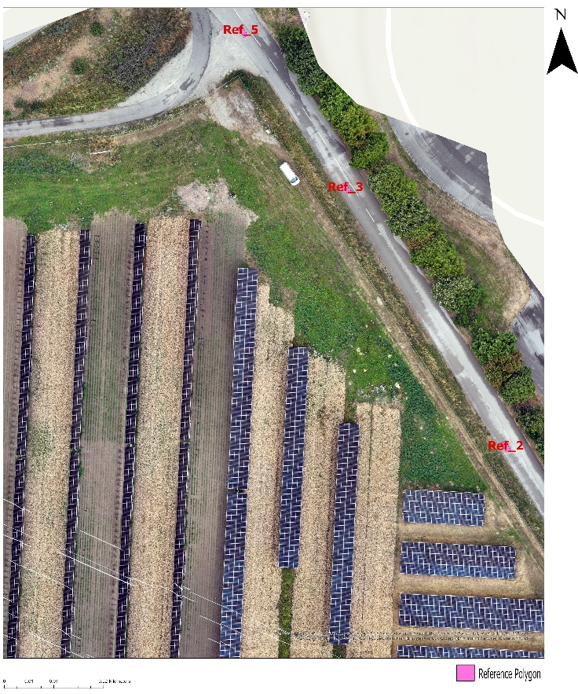
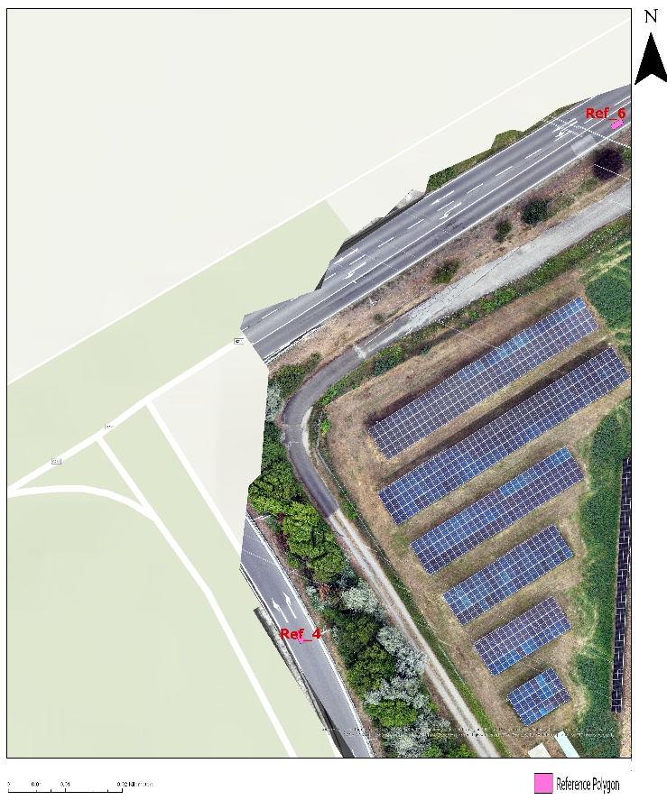

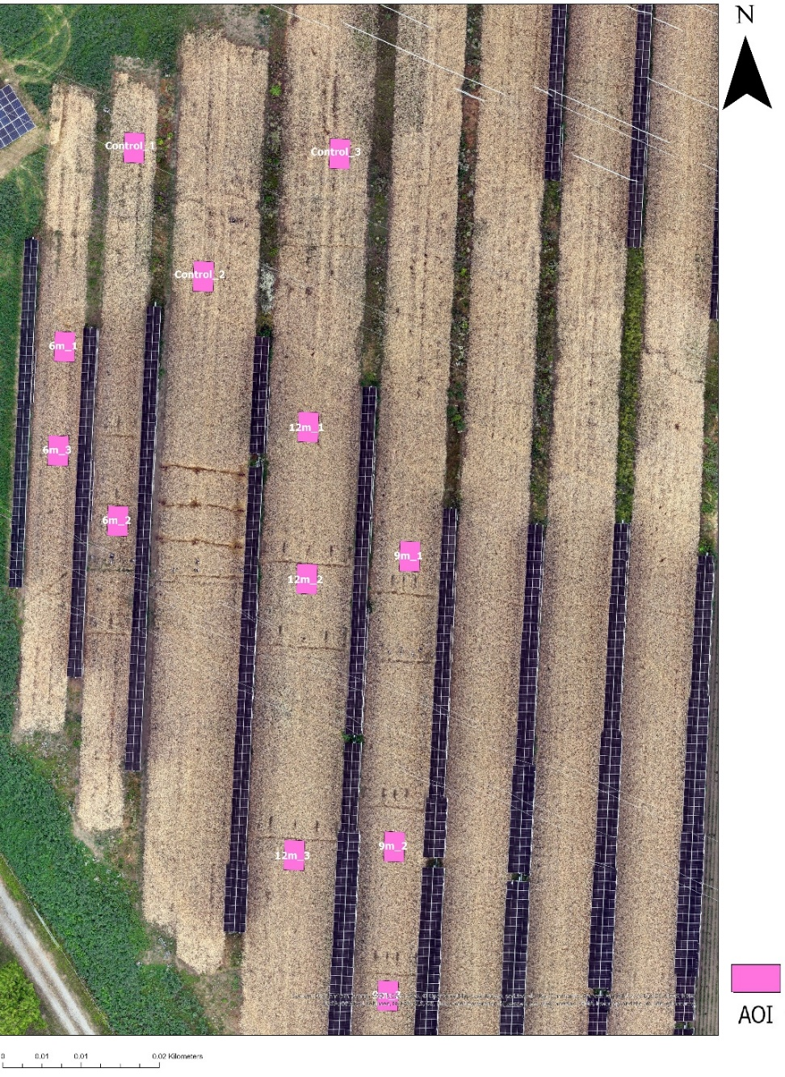

2. DSM Reliability: Can the Drone DSM Be Used as a Ground Reference?

2.1 Self-inspection of the 23.03.2026 flight, bare-earth DSM
The DSM of flight on 23.03.2026 was inspected directly (metadata, coverage, and a full visual render) to judge its quality before relying on it as the ground reference for every later date's canopy height calculation.
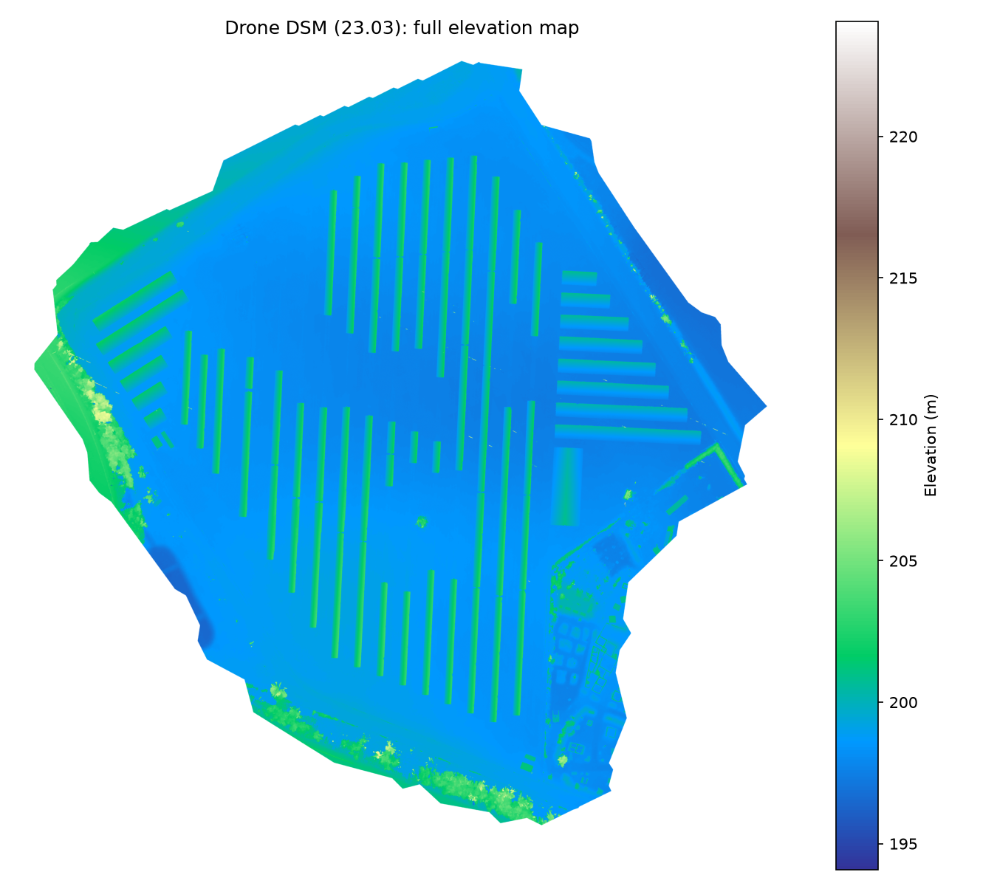
Figure 1. Full elevation map of the 23.03 DSM.
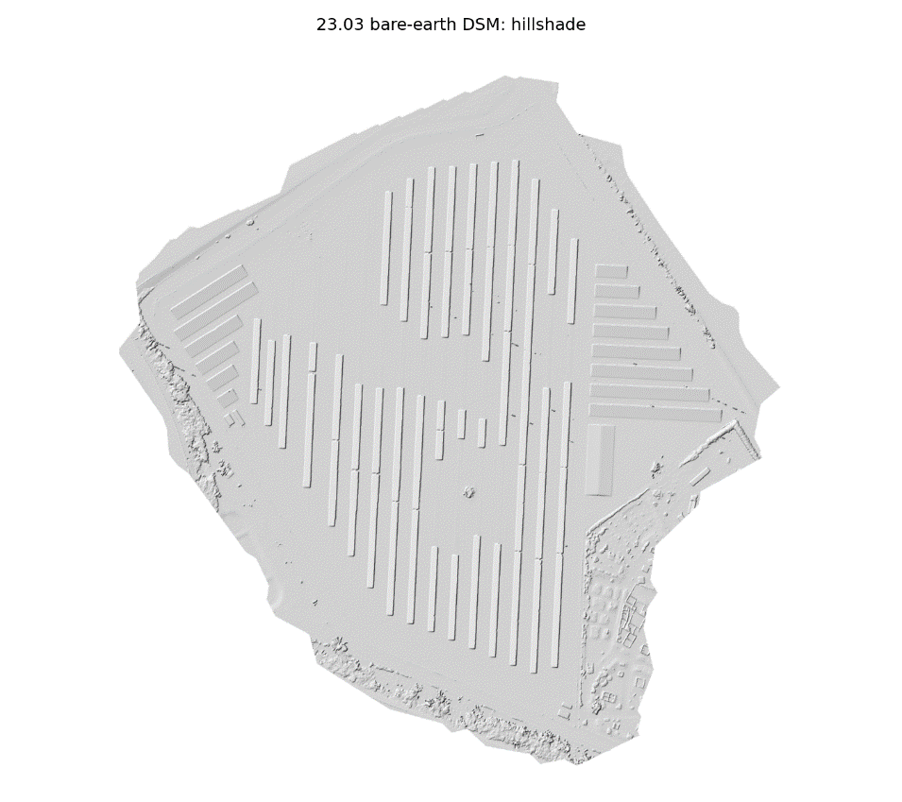
Figure 2. Hillshade of the 23.03.2026 DSM — field tramlines, PV row footprints, and field boundaries are all clearly resolved with no blocky seams or stitching artifacts.
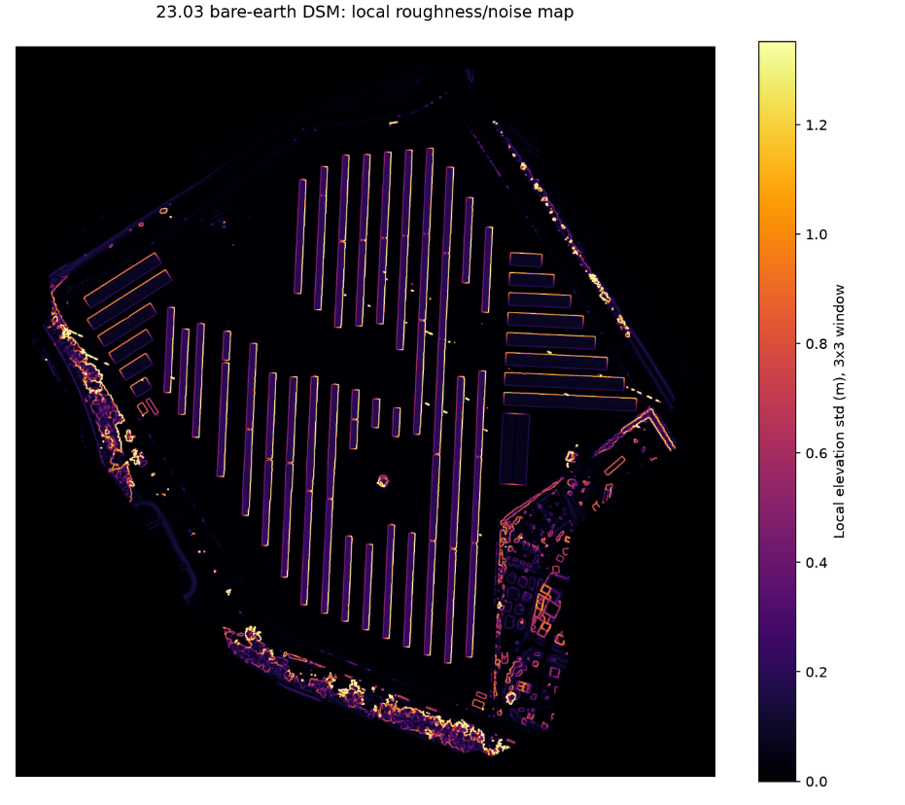
Figure 3. Local roughness (elevation std in a 3x3 pixel window). The open bare-soil aisles between PV rows — exactly where the crop AOIs sit — are uniformly dark (low noise), confirming a clean, low-noise ground surface reconstruction where it matters most for this study.
The DSM shows complete coverage of the surveyed area with no visible data gaps, a physically plausible elevation range, and clean, artifact-free terrain detail. The roughness map confirms low point-cloud noise specifically in the open field areas used for the crop AOIs (bright edges are expected at the sharp physical boundaries of PV rows and field edges, not a data quality concern). Together, this supports using the 23.03.2026 DSM as a reliable bare-earth reference surface.

2.2 Government DGM cross-check: explaining the constant offset
The drone DSM (ellipsoidal height, GRS80/WGS84) and the government DGM (orthometric height, EPSG:9274 – EVRF2000 Austria height, referenced to the Adria/Trieste datum) are measured relative to two different reference surfaces. The relationship is h = H + N, where N is the geoid undulation at the site — the physical separation between the ellipsoid and Austria's official sea-level datum at that location.
This offset was independently verified against the official Austrian geoid model (BEV Austrian Geoid 2008, GRS80, EPSG transformation 9276) at the farm's coordinates:

Quantity | Value
Empirically measured offset (DSM − government DGM, median across 12 AOIs) | 44.188 m
Official geoid undulation N (BEV Austrian Geoid 2008, GRS80, EPSG transform 9276), computed at farm coordinates (16.8173°E, 48.0364°N) | 44.229 m
Difference between empirical offset and official geoid model | 0.041 m

The 4 cm agreement between the empirically measured offset and the officially modeled geoid undulation confirms the observed 44 m gap is the expected ellipsoidal-to-orthometric height difference — not a processing error, and not an assumption, but a value independently reproduced from an official geodetic model.

2.3 Spatial residual map
After removing the constant vertical offset, the drone DSM and government DGM were differenced pixel-by-pixel across the whole farm to check not just the average agreement, but where any disagreement occurs.
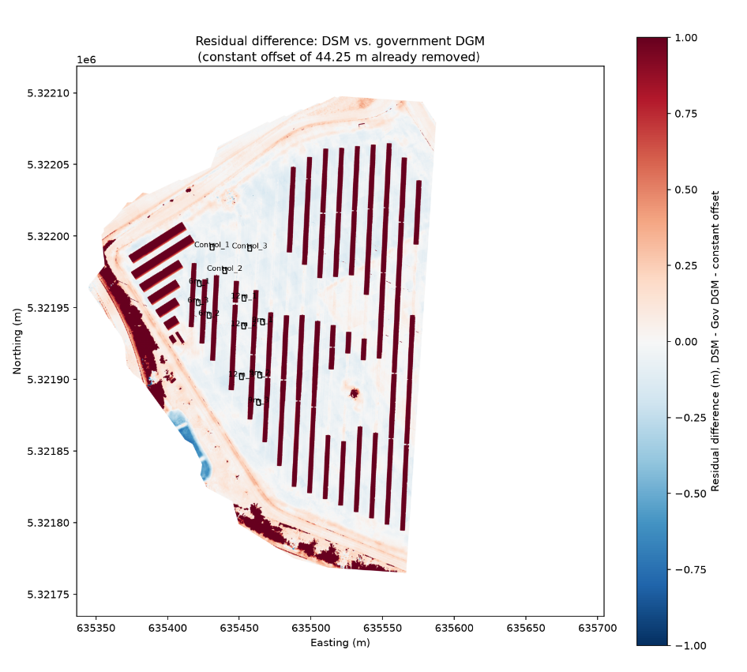
Figure 4. Residual difference map (DSM 23.03.2026 drone flight − Gov DGM − constant offset), with crop AOI boundaries overlaid.
The dark red stripes exactly match the PV panel row footprints — this is expected, not an error: the drone DSM captures the physical PV structures themselves (elevated well above ground), while the bare-earth government DGM naturally does not include them. In the open aisles between rows, where all 12 crop AOIs are located, the map is pale/near-white, confirming close agreement specifically in the areas used for canopy height measurement.
AOI | Residual mean (m) | Residual std (m)
6m_1 | -0.089 | 0.018
6m_2 | -0.072 | 0.022
6m_3 | -0.050 | 0.012
9m_1 | -0.025 | 0.012
9m_2 | -0.068 | 0.014
9m_3 | -0.063 | 0.015
12m_1 | -0.048 | 0.011
12m_2 | -0.067 | 0.015
12m_3 | -0.101 | 0.017
Control_1 | -0.054 | 0.008
Control_2 | -0.030 | 0.009
Control_3 | -0.076 | 0.017
All 12 crop AOIs show a small residual (−0.10 m to −0.03 m, std around 1–2 cm), well within the combined precision limits of the two datasets (government DGM: ±0.5 m stated accuracy; drone DSM: sub-decimeter). This is a tight, consistent result.

3. Reference-Surface Drift Check Across the Season
Six fixed reference polygons (Ref_1–Ref_6), placed on roads and paths that do not change height over the season, were tracked across all six flight dates to test whether each flight is internally consistent with 23.03.2026.

Date | Mean drift vs. 23.03 (m) | Std across 6 references (m)
2026-03-23 | 0.000 | 0.000
2026-04-20 | -0.019 | 0.037
2026-05-18 | +0.031 | 0.044
2026-06-15 | -0.099 | 0.038
2026-06-23 | -0.018 | 0.028
2026-07-08 | -0.009 | 0.024

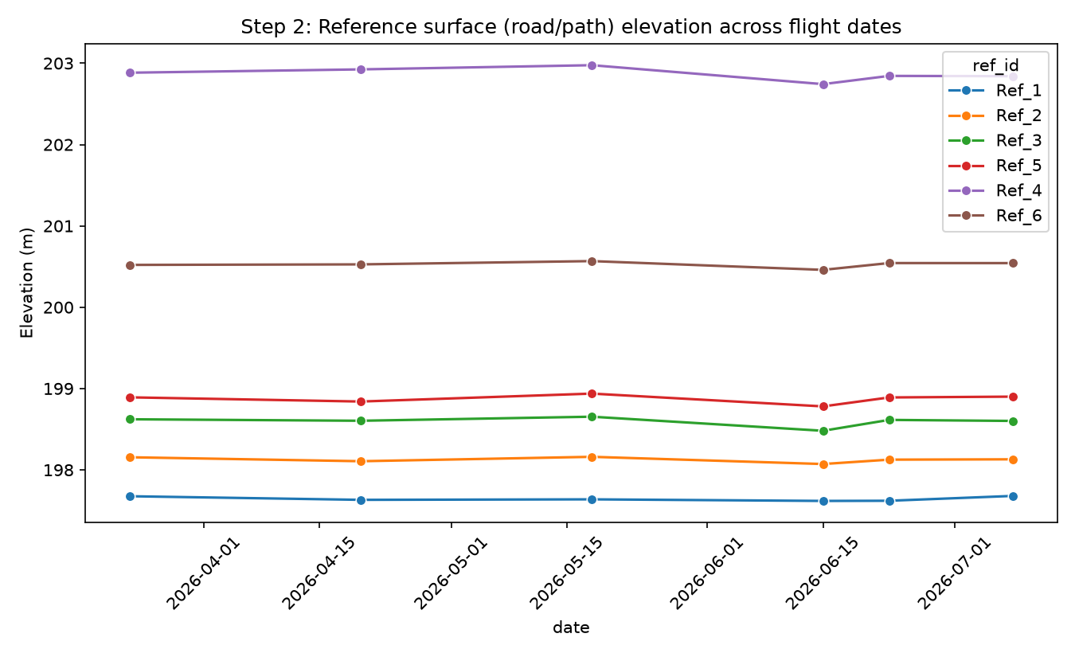
Figure 5. Reference surface elevation across flight dates — stays essentially flat.

Drift on stable surfaces stays within about 2–10 cm across the whole season — normal photogrammetric noise, not a systematic bias — and does not correlate with the much larger canopy height growth seen in the crop zones. This confirms the season's height growth reflects real plant measurement rather than a processing artifact.

4. Canopy Height Model (Plant Height)
Mean canopy height per zone, per flight date (meters):

Date | 6m | 9m | 12m | Control
2026-03-23 | 0.000 | 0.000 | 0.000 | 0.000
2026-04-20 | 0.043 | 0.084 | 0.101 | 0.061
2026-05-18 | 0.433 | 0.402 | 0.542 | 0.317
2026-06-15 | 0.558 | 0.613 | 0.720 | 0.583
2026-06-23 | 0.406 | 0.480 | 0.788 | 0.654
2026-07-08 | 0.676 | 0.810 | 0.847 | 0.705

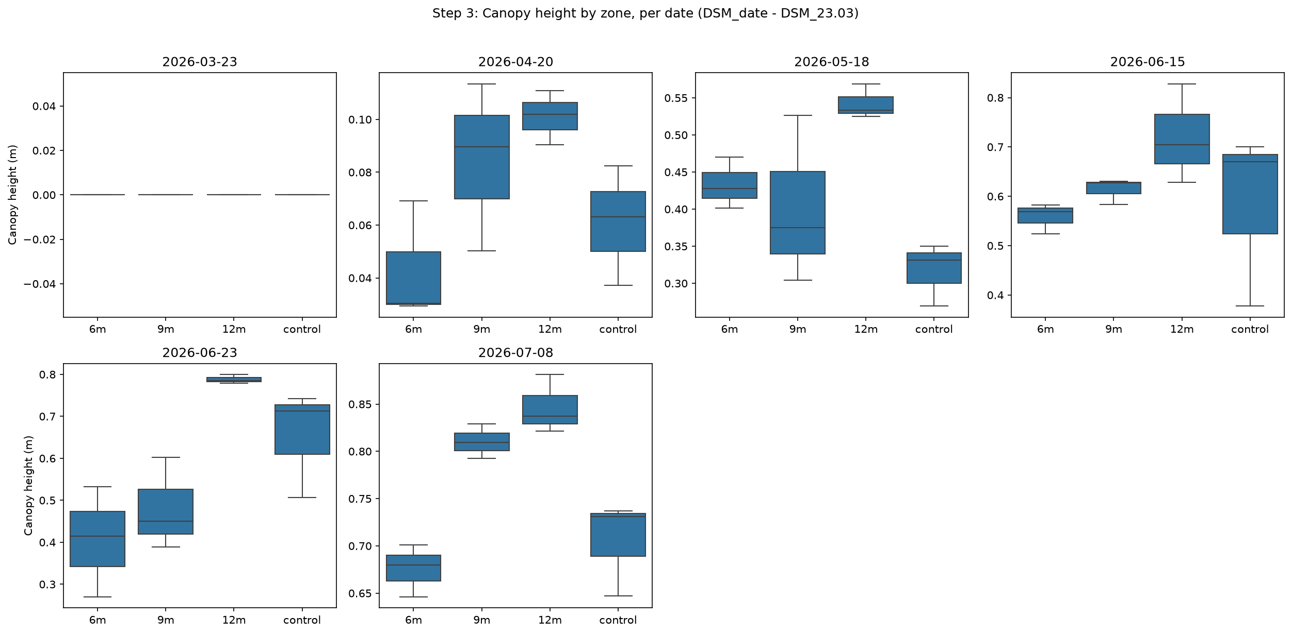

Figure 6. Canopy height by zone, per date.
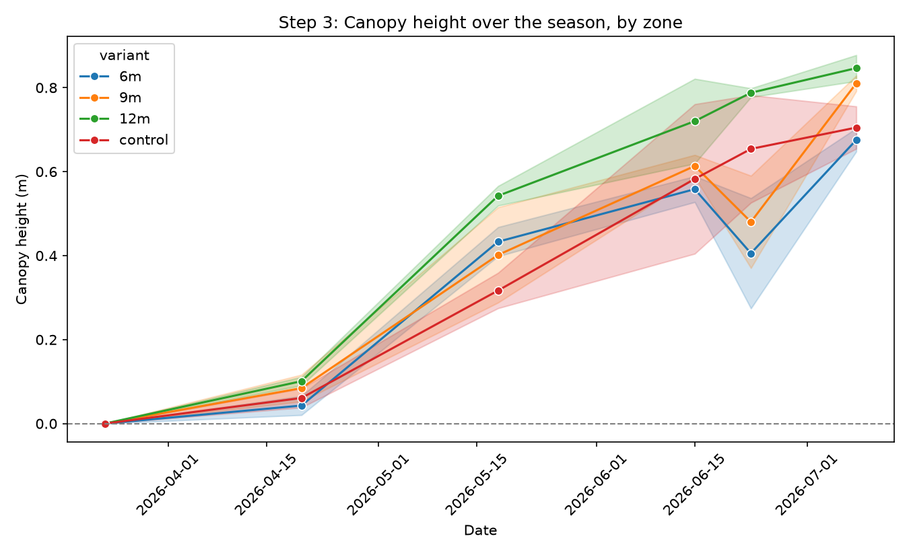
Figure 7. Canopy height over the season, by zone.

5. Key Findings
- The 23.03 DSM passed a full self-inspection: complete data coverage, plausible elevation values, clean artifact-free terrain, and low point-cloud noise in the open field areas used for AOIs.
- The ~44 m offset against the government DGM is fully explained: it matches the officially modeled geoid undulation for this exact location to within 4 cm, using BEV's own published geoid model — not an assumption, a verified geodetic fact.
- The spatial residual map shows near-zero disagreement specifically in the open aisles where the crop AOIs are located; the only large residuals are the PV panel structures themselves, which is physically expected.
- Reference-surface (road) elevations stayed flat within 2–10 cm all season, confirming the drone flights are well co-registered with each other.
- Wheat height rose from 0 m (23.03.2026, bare soil) to approximately 0.68–0.85 m by 08.07, consistent with expected winter wheat growth over a full season.
- 12m was the tallest zone on nearly every date, and 6m was generally the shortest during the main growth period (20.04.2026–15.06.2026) — consistent with the PV-proximity vigor effect already found in the NDVI analysis.
- 23.06.2026 shows an irregular dip for 6m and 9m (with unusually high within-zone variance); the reference-surface check rules out a flight-wide registration issue as the cause, so this is more likely localized measurement noise or real short-term crop variability, and should be interpreted with some caution.

6. Conclusion
The drone-derived DSM data is validated as a reliable reference through three independent lines of evidence: a clean self-inspection of the raw DSM, a geodetically-explained and independently-confirmed offset against the government terrain model, and a spatial residual map showing close agreement exactly where the crop AOIs are located. On this foundation, the season's canopy height results show a growth pattern consistent with known winter wheat phenology, and the 12m-tallest / 6m-shortest pattern during active growth reinforces the PV-proximity effect already identified through the vegetation index analysis — adding a structural (height-based) line of evidence alongside the spectral (NDVI-based) one. The 23.06.2026 anomaly remains a good candidate for a closer manual check before being included in any formal statistical comparison.

References

- Bundesamt für Eich- und Vermessungswesen (BEV) (2025). Digitales Geländehöhenmodell (ALS-DGM) – Höhenraster 1m, Kachel CRS3035RES50000mN2750000E4800000, Stichtag 15.09.2025. Available at: https://data.bev.gv.at. DOI: https://doi.org/10.48677/0ec47a0a-fb80-4862-95c8-f5c198379116. Licensed under CC-BY-4.0.
- EPSG Geodetic Parameter Registry. EPSG:9274 – EVRF2000 Austria height. https://epsg.io/9274
- EPSG Geodetic Parameter Registry. EPSG:5778 – GHA height (Gebrauchshöhen Adria). https://epsg.io/5778
- EPSG Geodetic Parameter Registry. EPSG:3035 – ETRS89-extended / LAEA Europe. https://epsg.io/3035
- BEV / EuroGeographics (2008). Austrian Geoid 2008 (GRS80), EPSG transformation 9276, geoid grid at_bev_GEOID_GRS80_Oesterreich.tif. Distributed via PROJ datum grid registry, https://cdn.proj.org/
- Bundesamt für Eich- und Vermessungswesen (BEV). TransDatPlus – Koordinaten- und Höhentransformation. https://transdatplus.bev.gv.at/
- Gillies, S., et al. (2013–2025). Rasterio: geospatial raster I/O for Python programmers. https://rasterio.readthedocs.io/
- Jordahl, K., et al. (2013–2025). GeoPandas: Python tools for geographic data. https://geopandas.org/
- Virtanen, P., et al. (2020). SciPy 1.0: fundamental algorithms for scientific computing in Python. Nature Methods, 17, 261–272.

